STEP 1: ACCESSING YOUR PORTFOLIO

1. |  | Type in your EMAIL ADDRESS and PASSWORD
2. | 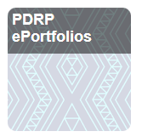 | Tap onto PDRP EPORTFOLIOS
3. | 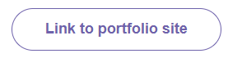 | Tap into LINK TO PORTFOLIO SITE
4. |  | Tap on the MENU (right hand top corner)
5. | 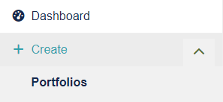 | Tap onto CREATE and then PORTFOLIOS
6. | 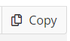 | On the right hand side, tap on COPY
7. | 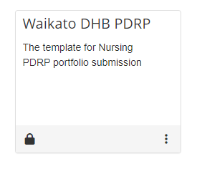 | Tap on the TEMPLATE – WAIKATO DHB PDRP
8. |  | Tap on COPY PAGE

STEP 2: EDITING YOUR CONTENT –CREATING YOUR PORTFOLIO PAGE

9. | 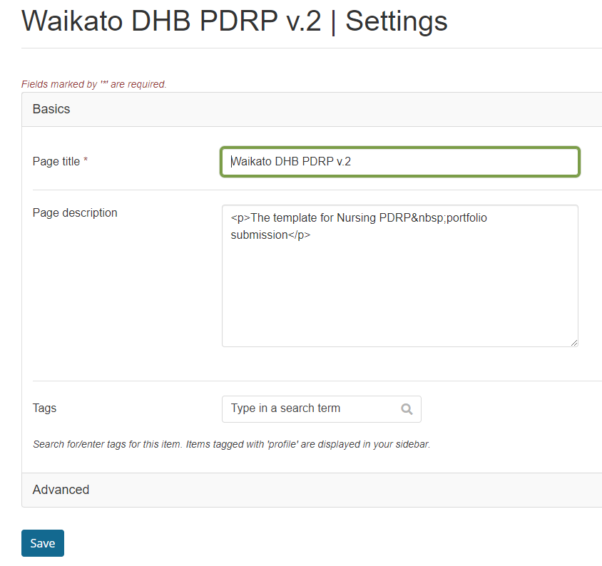 | - Using “Page Title Section” Type in your First Name, Surname, PDRP Level and Year e.g.  Jane Citizen Competent 2021.  Scroll to bottom of page and Click Save.  - For non DHB applicants, please add NON DHB after the Year e.g.  Jane Citizen Competent 2024 Non DHB.  Scroll down to bottom of page Click Save.
10. | 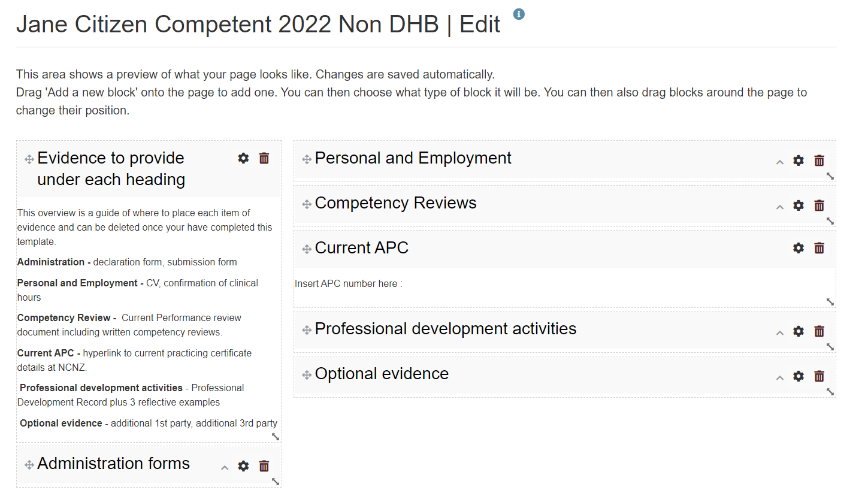 | You will now see your ePortfolio divided into sections e.g. Administration, Personal & Employment etc and the explanation of what is required in the content which is required to be uploaded into each section.  You are now ready to upload your documents.

STEP 3: UPLOADING DOCUMENTS

11. |  Click on this icon. | Each section will have a configure icon opposite it on this edit screen.
12. | 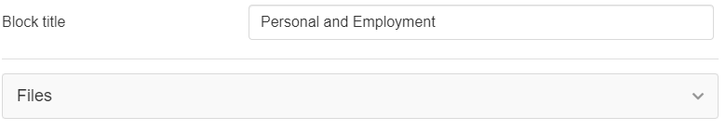  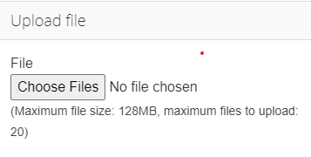 | - To Upload Files  - Click on“Files”  - Choose File  - ” Click Save.

Note: If you upload the incorrect file, click the Remove button on the right hand side of the file. DO NOT use the rubbish bin on the main block as this will delete the whole block and you cannot recover it. PLEASE DO NOT CHANGE THE TEMPLATE.

STEP 4: FINAL STEP – SHARING WITH APPROPRIATE GROUP

12. | 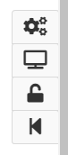 | On the right hand side of your portfolio  Click on the padlock
13. | 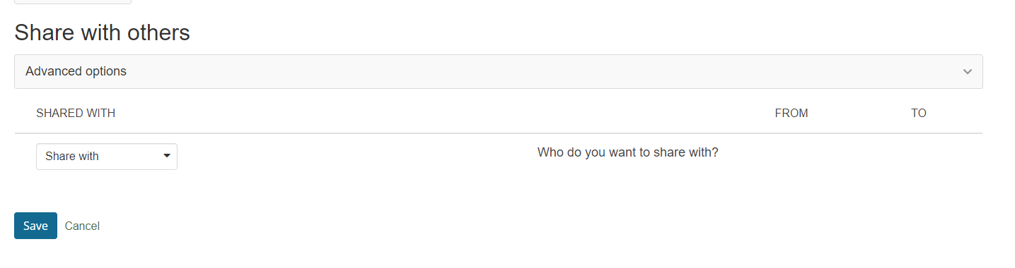 | Share your portfolio with:  Group  Waikato PDRP Portfolios 2024  From: enter date - submission  To: enter date – 6 months ahead  Save

Your portfolio has now been submitted and the PDRP Administrator will acknowledge receipt of the portfolio.
Please email pdrpteam@waikatodhb.health.nz to notify us that you have submitted your portfolio.

TO MAINTAIN CONFIDENTIALITY OF YOUR PORTFOLIO

The PDRP team will share your portfolio with the assessor when one becomes available and you will be notified who this assessor is via your portfolio ‘comments’ section.

Throughout the whole assessment process, your portfolio is only visible to the Admin team and your assessor.
.

